CapCut Instruction Manual (Short Version)

# 1. Getting Started

Download & Open CapCut.

- Tap "New Project" to start.

-Select all wanted videos (or you can add them later on when editing see Importing Clips)

This is what it looks like:



This is your editing timeline:

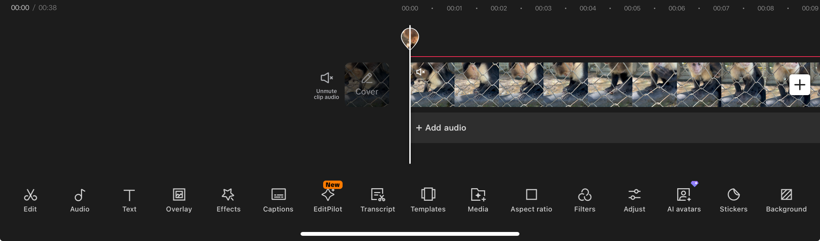

This is all the features you will use: 

# 2. Importing Clips

Tap "+" to import videos/photos.

- Arrange clips by dragging them on the timeline.

# 3. Basic Edits

- Trim: Tap clip -> drag edges to shorten.

- Split: Tap clip -> tap "Split" to cut.

- Delete: Tap clip -> tap "Delete".

-Speed: Tap clip -> tap “Speed”

# 4. Add Text

- Tap "Text" -> "Add text".

- Type your message.

- Customize font, color, and animation.

# 5. Add Music or Sound

- Tap "Audio" -> "Sounds" or "Extracted" (from your device).

- Adjust volume or trim audio length.

-To add audio from another video-> Tap “Overlay” and “Add Overlay” and select desired clip

-Once the clip is added drag it out of the screen

-you can now mute the original video while the audio from the overlay video is playing

It will look like this:

(Two videos on top of each other, the video we will see is in the first line and the video we will hear in the second (audio line), as you can see the top left of the top video in the editing part, there is a small muted sign.)



# 6. Effects & Transitions

- Tap "Effects" for filters or visual effects.

- Tap the white square between clips to add transitions (e.g., fade, zoom).

# 7. Captions

-Tap “Captions”

-If taken from the video click “Generate from: Video” but if its from an added audio click “Generate from: Voiceover”

-Make sure to specify the language in the “Spoken Language”

-Select the Style of the captions in the “Template” section

# 8. Adding Stickers or Images

Stickers:

-Tap “Stickers”

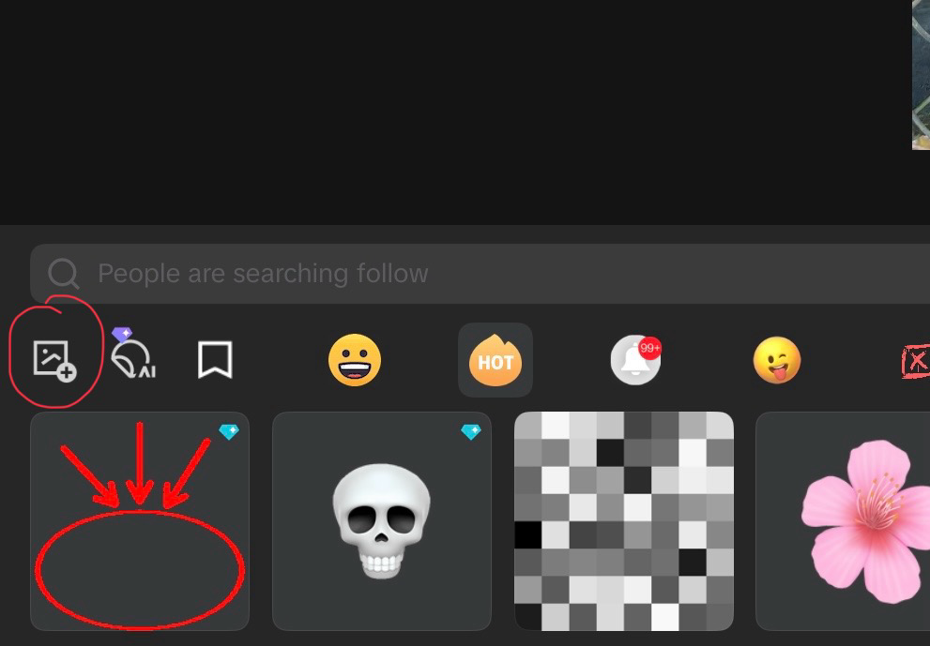-You can choose an available sticker or create one from a picture by clicking the little image icon with a plus

Image:

-Tap “Media”

-Tap “Library” and select desired image

# 9. Format & Export

-Tap “Aspect Ratio” to change the video ratio to fit the Instagram or Tik tok size

- Tap "Export" (top right corner) to save.

For any questions feel free to contact me at jasmine.bourgoin@mail.mcgill.ca